ТЕКСТ 9.1
- Read the text.
THE COMPANY ORGANIZATION

Company is an association of persons officially formed for the purpose of some business. It is often headed by the board of directors. The board headed by the chairman usually consists of individuals elected by the shareholders to manage the business. The directors are active in the day-to-day operation as company policy and broad general direction.
Look at the structure of a typical big company in the diagram:
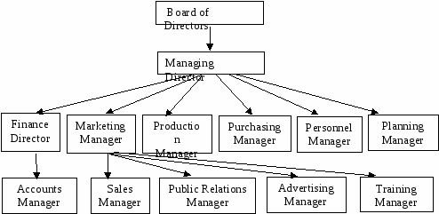

Pay attention to fact that American job titles differ from British ones. These are rough equivalents:
British | American
Chairman | President
Managing Director | Chief Executive Officer
Director | Vice President
Accountant | Financial Controller
Manager | Director

Companies belong to various areas of business, such as: engineering, microelectronics, chemicals, vehicle manufacturing, aerospace, shipping, transport, retailing, catering, insurance, banking, etc.

Vocabulary

board - правление, совет
chairman - председатель
shareholder - акционер
to purchase - покупать
engineering - машиностроение, техника
vehicle - средство перевозки (автомобиль)
space - космос
shipping - грузовые перевозки
catering - сфера общественного питания
insurance - страхование

2. Answer the following questions:
1. How is the company defined?
2. What body is usually at the head of the company?
3. Who elects it?
4. Is the Board of Directors responsible only for day-to-day operation of the company?
5. How many directors and managers compose the Board of Directors according to the diagram?
6. To whom dose the Advertising Manager report?

3. Match the English words and word combinations with their Russian equivalents.
1. chairman | a. правление компании
2. managing director | b. председатель
3. marketing manager | c. менеджер по рекламе
4. production manager | d. менеджер по маркетингу
5. works manager | e. начальник производства
6. purchasing manager | f. менеджер по работам
7.sales manager | g. менеджер по закупкам
8. chief accountant | h. менеджер по продажам
9. advertising manage | i. главный бухгалтер
10. training manager | j. менеджер по подготовке кадров
11. board of directors | k. управляющий по административно- хозяйственной работе

