Information about the city
​​Krasnoyarsk is the largest industrial and cultural center of Eastern Siberia, and capital of Krasnoyarsk Territory, the second largest region in Russia by area. It is situated in the centre of Russia at the confluence of the small river Kacha and mighty Yenisei. The town was founded in 1628 by Cossacks under troop leader Andrey Dubenskiy’s command and was originally named ”Krasniy Yar”.
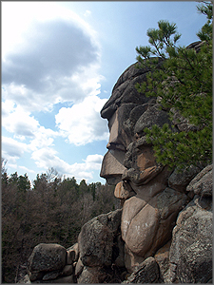
The city is distinguished by its unique landscapes, mountain views, majestic Siberian forest and well-known Stolby Nature Reserve. This work of nature is a series of exotic rocky eminences situated in the taiga on the spurs of the Eastern Sayan Mountains. The territory of the reserve totals 47 000 hectares.
Today’s Krasnoyarsk is a modern industrial city with unique architecture, a capital of artistic and talented people of Siberia and one of the most beautiful cities in the country. As of January 1, 2018, more than 1 091 600 people live in Krasnoyarsk.
Several years in succession, Krasnoyarsk has been recognized as one of the most ‘comfortable’ cities in Russia. A number of various projects and programs, directed to the improvement of urban environment, are realized in Krasnoyarsk, among which are the following: “My courtyard”,” Clean Entrance – Clean City” and two months of beautification and arrangement of green spaces “Clean City, Clean Siberia”. In May 2004, drinking water in Krasnoyarsk was awarded a gold medal at the International” Great Rivers - 2004” forum.
Krasnoyarsk is a city with actively developing business infrastructure. Over 44 000 enterprises, including 522 large and medium enterprises and organizations, are situated in Krasnoyarsk. Krasnoyarsk takes the leading position in Siberia by volume of per capita industrial production. Alongside the traditional industrial sectors for the region, such as metallurgy, power engineering and mechanical engineering, new areas are developing more and more actively. Proposals and creation of ideas, technologies and projects allow the city to maintain its leading position and develop its attractiveness for investment. In 2006 Krasnoyarsk innovative-technological business incubator came into operation.
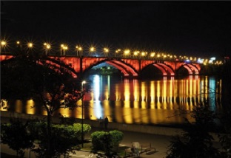As a result of the year 2008 Krasnoyarsk took the 1st place among cities of the Siberian Federal District by volume of average monthly salary, dispatched goods and investment of capital.
In the 1960’s, Krasnoyarsk became a major transport junction. Three of the most important transport routes, the Trans-Siberian railway, a highway of federal significance and the river Yenisei pass through the city.
Our city is actively built on. In recent years Krasnoyarsk has been among leaders in housing construction. Year 2006 was a record in the last years: 810 000 sq. meters of living space were constructed, as a result, our city became an absolute leader among republican, oblast and regional centers of Russia. In 2007-2008 volume of housing construction was quite large as well.
To increase affordability of housing, there are several programs for citizens. In 2003, a programme of municipal loan bonds for citizens was developed. The first rapidly erected block of flats was commissioned in December 2004. In addition, the city mortgage programme” For Young Families – Accommodation at a Reasonable Price “has been developed. Now the 4th house is under construction under this programme.
The city has rich cultural traditions. Great Russian artist, Vasiliy Surikov, writer Victor Astafyev, and opera singer Dmitry Khvorostovskiy were all born, educated and worked here. There are 5 professional theatres in Krasnoyarsk. Mikhail Godenko’s State Academic Dance Company of Siberia is known to spectators of more than 50 countries worldwide. 40 municipal cultural institutions are situated in Krasnoyarsk.
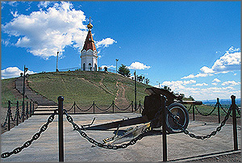
Krasnoyarsk is well known in Russia for its Paraskeva Pyatnitsa Chapel, for an architectural ensemble of office buildings on Karl Marks street, as well as for its Clock Tower.
Krasnoyarsk bridges are among the main sights of the city. The Railway Bridge over the Yenisei, constructed in 1899 by mechanical engineer E.K. Knorre as part of the project by known Russian engineer L.D. Proskuryakov, was awarded with gold medal at the World Fair in Paris in 1900 as the highest achievement of technical idea. Communal Bridge is one of the symbols of our city.
In 2003, a new symbol, the Historical Gates to the City, appeared in Krasnoyarsk. They were constructed at the exact place, where almost four centuries ago the settlement’s history began. In year of the 375th Anniversary of Krasnoyarsk, another tradition appeared – a carnival, which became one of the main events of City Day. The carnival procession annually includes over 10 000 people from creative and labour collectives of all large enterprises of the city. In 2009 a carnival of Krasnoyarsk was acknowledged a laureate of the Russian National Award «Facets of the mass theatre» in nomination «The Best Festive Event – City Day». Other large-scale city-wide initiatives were City Forum and Parents’ Forum. Assembly “Krasnoyarsk. Technologies of the Future”, which unites scientists, inventors, businessmen - all, who are interested in scientific and technical development of the city, was held twice in two years successively.
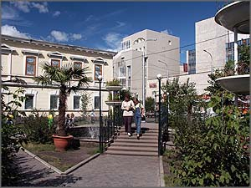
Krasnoyarsk is a city that has turned to the future. School education is a reason for pride and opportunity to declare its leadership in educational process of the whole country. Successes of schools of the last 3 years were recognized at the federal level under the National Project “Education”. Teachers of Krasnoyarsk are also take leading positions in Russia. More than 300 school teachers of Krasnoyarsk became laureates of various all-Russian competitions in last 3 years. Among their pupils are authors of scientific works, awarded at the Russian level, as well as winners of the All-Russian olympiads and contests.
Significant scientific potential is concentrated in Krasnoyarsk. Right here, in Krasnoyarsk, Siberian Federal University – higher educational institution of the “3rd millennium” - was established. It can be compared by its size only with the Moscow State University. Council of trustees of the university is headed by Russian President Dmitriy Medvedev.
Krasnoyarsk justifies its reputation of sports center of Siberia. 13 children and youth sport schools of the Olympic reserve, 83 federations of various kinds of sports, 70 sport clubs, 8 organizations of adaptive physical training and sports, work in the city. The "Everybody Starts" jogging competition has celebrated its 10th anniversary and the number of participants grows year after year. The Children's Olympic Games, in which pupils of all kindergartens and schools of the city participated, became a visiting card of Krasnoyarsk. Ivan Yarygin’s International Tournament in Free-Style Wrestling is annually held in Krasnoyarsk.
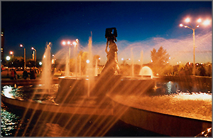
Krasnoyarsk is a symbol of bright victories in rugby, bandy (ice hockey with a ball) and free-style wrestling. Twice, in 1982 and 1986, Krasnoyarsk was host of the Winter Games of Peoples of the USSR, the biggest mass competition of the country. Names of prize-winners of the Russian, European and World championships in biathlon Olga Pyleva and Pavel Rostovtsev, pupils of the ‘Yenisei’ bandy team Lomanov father and son, Ivan Maksimov, Olympic champions in free-style wrestling Saytiev brothers, as well as Alexey Shumakov are known all over the world.
Krasnoyarsk is a city of health. The most important achievement of the year 2008 was that the annual average birth rate exceeded death rate for the first time over recent years. So, over 12 thousand newborns came into the world last year in Krasnoyarsk.
Everyone wishes to find the place on Earth where he would desire to live, meet dawn and see the sunset, study, work, build a house and bring up children. Krasnoyarsk is exactly such a place for its citizens. It is the city providing confidence in tomorrow, a city famous for its remarkable people and a unique history. Krasnoyarsk is a city, which every day enters bright and significant pages of its life into the annals of history.

Krasnoyarsk History
​​​​​​​​​​​​​​​​​​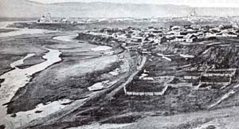Krasnoyarsk is one of the oldest Siberian cities. A military detachment of Cossacks led by Andrei Dubensky founded it in 1628 as a military fortress. Originally the settlement was named “Krasniy Yar”, which means “Beautiful bank”. Krasnoyarsk received status of the city in 1690, when Siberia was finally added to Russia. In 1822 was announced the tsar's decree to create Yenisei province, and Krasnoyarsk became the center of it.
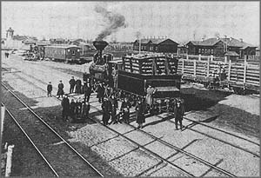In XVIII century Krasnoyarsk turned from a military fortress into an average Siberian city. The turning point for the city history was the construction of the Great Siberian Railway in 1895. This railway connected Krasnoyarsk with the central part of Russia.
It was followed by the construction of the railway station and the famous bridge over the Yenisei. Thus, Krasnoyarsk became the major traffic center of Siberia. In XIX century the city became the place for Decembrists exile. At that time were founded educational and cultural institutions, own newspaper started to be issued. Thanks to this the city received the status of cultural capital of Siberia.
Today, after almost four centuries from its foundation, Krasnoyarsk is the major industrial, transport, scientific, cultural and sporting center of the East Siberia and the capital of the second largest region of Russia. There are 150 large- and medium enterprises functioning in the city. Krasnoyarsk has also been recognized as one of the most comfortable cities of Russia.
Krasnoyarsk history started in 1623, when Yenisei voivode Yakov Ignatievich Khripunov sent boyar’s son Andrei Anufrievich Dubensky to choose the place for a new fortress to secure Yeniseysk against Kirghiz raids. For the construction of the new fortress Dubensky chose a place that was four-days horse ride away from Yeniseysk, near the north line of the Kirghiz nomads' camp at the high plane promontory between river Kacha outfall and Yenisey, where its left bank – composed of red marl - rises up steeply and forms picturesque ridge. The place, chosen for the fortress, was named Krasny Yar ("red bank") by Dubensky, quite probably not because of the precipitous bank color but for the beauty of this place (as "krasny" in old Russian also meant "beautiful"). In 1627, when the building plan was approved in Tobolsk and Moscow, 303 men led by Andrei Dubensky had been equipped for campaign. With great difficulties the expedition reached the place and began to build the fortress in the middle of summer 1628. It is necessary to note that local residents were very peaceful and even helped in construction. According to historical documents "the prince of the near Tyulkina land - Tatysh met the Russians with peace and gave them horses". At the end of July 1628 Kirghiz tested the patience of the newly erected fortress and its defenders. The attack was successfully repulsed as well as the multiple further assaults on the Siberian stronghold. At times the fortress had been under a siege for months, but had never been seized by the enemies.
Cossacks were the first and the only inhabitants of the “New Kacha Ostrog”. That was the previous name of Krasnoyarsk. At the beginning of XVIII century the garrison consisted of 850 people, 80% of which were military men. As all Russian Cossacks in XVII —XVIII centuries, they were soldiers, officials and workmen simultaneously.
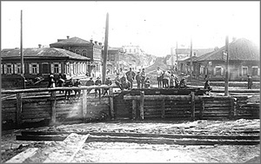In 1690 Krasnoyarsk received the status of the city. Krasnoyarsk lost the strategically importance of the military outpost after the Yenisei Kirghiz defeat, the departure of some of their princes to the Tien-Shan foothills, the construction of Abakan and Sayan fortresses and the signing of the Peace Treaty at Kyahta with Manchuria in 1728. Peace came to the city but it also brought a stop to its development.
In 1782 the Yenisei province, established at the times of Peter the First, was liquidated. This province covered almost the whole of current days Krasnoyarsk Region. The territory of the Krasnoyarsk Uezd was divided between three regions ruled by governor-general: Tobolskoe, Kolyvanskoe and Irkutskoe. Krasnoyarsk was subordinated to Tobolsk, but still preserved its previous administrative significance. Since 1804 Krasnoyarsk was subordinated to Tomsk, which became the principal city of the province.
The transformation of Krasnoyarsk from the big frontier stronghold to a usual small Siberian town had an impact on all spheres of its life. At the last quarter of the century the city appearance had no reminder about its warring past. In 1773 an awful fire destroyed all fortifications and left only 30 houses untouched.
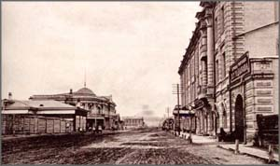The city life changed, when in 1822 tsar's decree to establish Yenisei Province was issued. Krasnoyarsk was chosen to be its center, it was not a big city, but it had the most advantageous economic-geographic position. At this time there were functioning telegraphic station, primary school, men’s and women’s gymnasiums, teacher’s seminary and handicraft specialized school. Merchants, craftsmen and owners of goldmines went to Krasnoyarsk, first stone buildings were constructed, a park was laid out, a printing establishment was opened and the first Krasnoyarsk newspaper “Yenisei province record” was published.
Another important date for Krasnoyarsk is December 6, 1895. It was time when the first train opened the traffic on the Trans-Siberian Railway. The construction of this railway significantly facilitated the development of the city.
In 1934 Krasnoyarsk became an administrative center of the region with rapid development of industry. At the beginning of 1941 there were 38824 people working at the city enterprises. The industrial power of Krasnoyarsk was increasing during the war period and it became the major industrial center of East Siberia, outrunning Irkutsk.
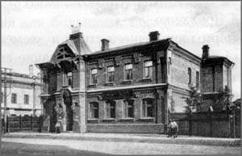A new page of city history was the development of the hydropower resources of Angara and Yenisei, which began during the post-war period. At the time of industrial rise both electrical power industry and related enterprises like ferrous and nonferrous metallurgy, pulp-and-paper industry, medical and chemical industries were created here. Krasnoyarsk became the major center of academic science, higher and specialized secondary education. Today there are 47 research organizations, 12 state institutions of higher education and 35 technical colleges in the city. Krasnoyarsk is the cultural center of the region. There are Theatre of Opera and Ballet, Dramatic theatre, Theatre of Musical Comedy, Theatre for Young Audience, Puppet Theatr​e, Picture Gallery, Local History Museum, Surikov Museum, Symphony Orchestra, Organ Hall in the city. And it is necessary to note famous Mikhail Godenko’ Siberian folk dance group.
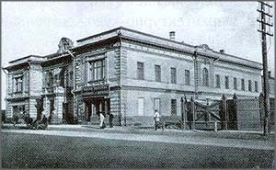Today Krasnoyarsk is the city with population of more than a million people, the geographical center of the country and the biggest main traffic center of Siberia. There are tens thousand enterprises, organizations and institutions in the city. The fourteenth city by the number of inhabitants, Krasnoyarsk is the administrative center of one of the biggest federal regions in Russia – the Krasnoyarsk Region, which area is about 2339,7 thousand square kilometers or 13.6% of all country’s territory.

Awards of the city
During its long history Krasnoyarsk had been awarded and mentioned more than once both by the government of the USSR and the Russian Federation and by the various influential international organizations.
On August 10, 1978 Krasnoyarsk was awarded by the Order of October revolution for the significant contribution to a process of formation, defense and development of the country. The Order of October revolution was instituted by decree of the Presidium of the Supreme Council of the USSR on October 31, 1967. This Order was awarded to the citizens of Russia and other states, to enterprises, institutions, settlements for their active revolutionary work, for their contribution to formation and consolidation of the Soviet rule, for achievements in the sphere of national economy, science and culture, for their courage and bravery shown in the battles, as well as for efficient government and social activity.
In 2000 Krasnoyarsk took the third place in the contest “The most comfortable city of Russia - 2000”.
On December 17, 2001 Krasnoyarsk was awarded by the Peter the Great Order. The Order of Peter the Great is the most superior social award of the Russian Federation; it is awarded for the outstanding services to the Motherland, promoting prosperity, greatness and glory of Russia.
In 2001 Krasnoyarsk got the prize of the All-Russian contest of the financial improvement of the Russian economy “The Golden rouble”. Krasnoyarsk won in nomination “The best Russian city by the economic indexes of financial improvement of the economy in 2001”.
In 2003 Krasnoyarsk took the third place in the contest “The most comfortable Russian city” by the results of 2002.
In 2004 Krasnoyarsk was acknowledged the laureate of the All-Russian special prize “Russian creators” in nomination “Construction investment”. The prize “Russian creators” is a Russian national award, which is given to the best representatives of building sector – building companies, associations, funds and other building institutions, as well as to people, who became famous in the field of construction. This prize is the evidence of the superior achievement in professional activity and the laureates’ significant contribution to the Russian social sector.
In 2006 Krasnoyarsk was acknowledged the winner in nomination “The best Russian city by indexes of economic development” at the All-Russian contest of the Russian economic development “Golden rouble”. This prize was awarded to Krasnoyarsk for the high rates of the socio-economic development and for the important achievements in various branches.
In 2006 the United Nations Organization proclaimed Krasnoyarsk as “the city comfortable for life”.
​In 2007 Krasnoyarsk took the second place in the contest “The most comfortable Russian city” by the results of 2006.
On April, 2008 Krasnoyarsk was awarded by the Diploma of the first international review-contest “The best CIS city” for the formation of the effective model of the social support of population.

